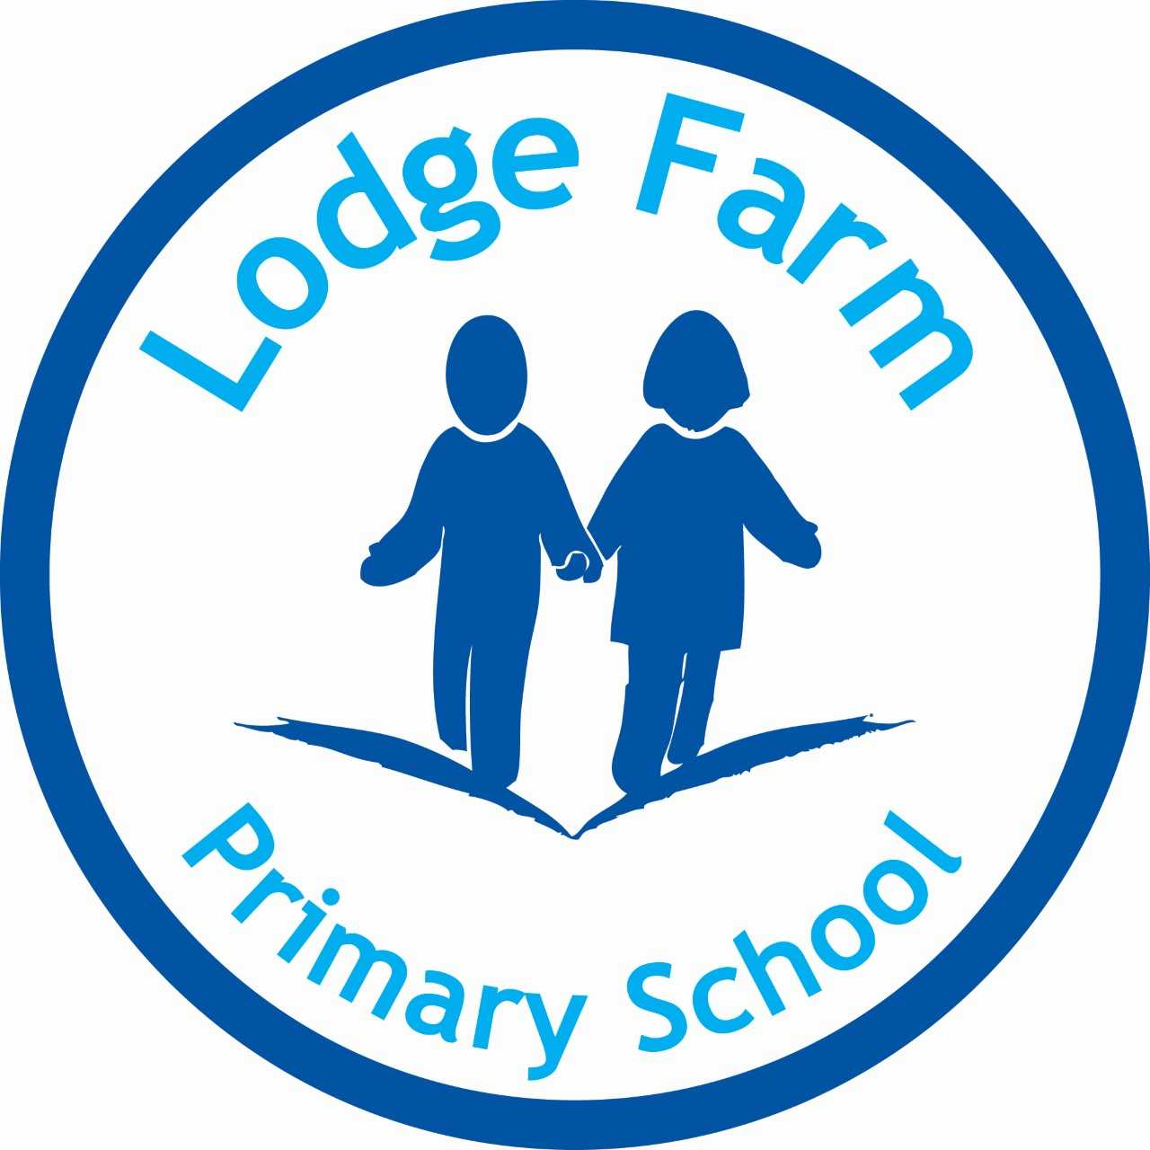

R.S.E. Policy

P.Bradnock

November 2023
(Awaiting Approval)

Approved by Chair:

Review Date:

Statutory Policy

Rationale and Ethos

Relationships and Sex Education (RSE) is a lifelong learning process of acquiring information, developing skills and forming positive beliefs and attitudes about sex, sexuality, relationships and feelings.

Effective RSE can make a significant contribution to the development of the personal skills needed by pupils if they are to establish and maintain relationships. It also enables young people to make responsible and informed decisions about their health and wellbeing.

This policy aims to offer additional support on new issues not included within existing guidance;
- It will provide advice, which reflects updated legislation, including the Equality Act 2010 and the RSE Heath Education Statutory guidance for September 2020.

Other related policies include PSHE, Science, Safeguarding, Confidentiality, Behaviour, Inclusion, Anti-Bullying, Health and Safety, External visitor, Equality, E-Safety and Extreme Radicalisation in schools.

At Lodge Farm Primary School, we believe that Relationships and Sex Education (RSE) should be set in the context of clear values, including the values of family life, marriage and of loving and stable relationships in bringing up children.
- It should teach children and young people to develop values, attitudes, personal and social skills and increase their knowledge and understanding to make informed decisions and life choices.
- RSE is important to ensure that children grow up with the ability to enjoy the positive benefits of loving, rewarding and responsible relationships; to be informed and comfortable with the changes during puberty; to be emotionally safe and sexually healthy. We teach pupils to be digitally safe with e-safety being a vital message throughout the school.

Effective RSE at Lodge Farm Primary School is dependent on partnerships at many levels; between our parents and carers, the children and young people and, at a more strategic level, between the local authority, local faith communities, health professionals, partners in children’s services and the voluntary community.

At Lodge Farm Primary School, we aim to achieve an effective Relationships and Sex Education programme through building on these partnerships and the continued professional development of staff. Enabling the delivery of a developmental, planned programme, that is integrated into the curriculum and delivered over an extended period.

Lodge Farm Primary School believes that Relationships and Sex Education (RSE) has four main elements:

- Attitudes and values – developing a moral code
- Learning the importance of values, individual conscience and moral considerations.
- Learning the value of family life, marriage and stable and loving relationships for the nurture of children, while recognising the diversity of family groups.
- Learning the value of love, respect and care, honesty and loyalty in relationships.
- Valuing diversity: an acceptance and exploration of difference, promoting equal opportunity, e.g. by considering media gender stereotypes and by being sensitive to the needs of culture and religion.
- Exploring, considering and understanding moral dilemmas.
- Developing critical thinking as part of decision-making.

2. Personal and social skills – important life skills
- Learning to manage emotions and relationships confidently and sensitively.
- Developing self-respect and empathy for others.
- Learning to make choices based on an understanding of difference and without prejudice.
- Developing an appreciation of the consequences of choices made.
- Taking responsibility for one’s own actions and learning.
- Communication skills.
- Listening sensitively to others’ opinions.
- Asking questions, expressing emotions and opinions, discussing issues openly and without embarrassment.
- Being assertive and an independent decision-maker.
- Reflecting on and evaluating information and opinions and understanding the impact of external factors, such as the media, Internet and peer pressure.

3. Negotiating with friends and others
- Practical skills.
- Caring for oneself and others.
- Being confident to access support and advice when needed.
- Decision-making skills: making sensible choices in the light of relevant information.
- Making moral judgements about what to do and acting accordingly.
- Solving problems.
- Managing conflict.
- Learning how to recognise and avoid exploitation and abuse.

4. Knowledge and Understanding
- Learning and understanding physical development through age-appropriate information.
- Understanding human sexuality, reproduction, sexual health, emotions and relationships and the right to confidentiality.
- Develop understanding of important knowledge and so correcting misconceptions and misinformation.
- Knowing what is legal and illegal in matters relating to sexual activity.

RSE is entwined within our PSHE curriculum and can be identified through our medium term plans and Long term plans. As a school, we have clearly defined the statutory elements of our curriculum and the non- statutory.
Roles and Responsibilities

Teaching staff are responsible for the delivery of lessons and key RSE messages. Teaching staff will receive ongoing training as required to support with developing awareness and needs. The PSHE lead will deliver training and resources to key staff members, who teach timetabled weekly lessons and will monitor and report to the Head Teacher and Governing Body at Lodge Farm Primary School.

The Head teacher will be responsible for:
- overseeing curriculum/policies and dealing with issues concerning withdrawal.

Safeguarding Lead will be responsible for:
- checking policy for safeguarding compliance and dealing with matters should they arise.

Parents/carers will be responsible for:
- working in partnership with the school by being conversant with school policy and supporting learning within the home environment.

Legislation (statutory regulations and guidance)

From 1st September 2020, we will be teaching Relationships and Health Education as part of the mandatory statutory requirements. See current legislation compliance below:
- Education Act (1996)
- Learning and Skills Act (2000)
- Education and Inspections Act (2006)
- Equality Act (2010)
- Supplementary guidance SRE for the 21st Century (2014)
- Children and Social Work Act (2017)
- Keeping Children Safe in Education – Statutory Safeguarding Guidance (2018)
- Relationships and Sex Education (RSE) and Health Education Statutory Guidance (published July 2019).

Curriculum Design

Our RSE program is an integral part of our whole school PSHE provision. It is also supported by statutory requirements as set out in the National Curriculum for Science, PE and Computing. We use a variety of approved resources to deliver our RSE Health & Relationships curriculum. The curriculum model we use is based upon best practice as established by national organisations such as PSHE Association, Sex Education Forum, Brook Advisory Service and Local Authority resources; this will ensure that our delivery is age and stage relevant. Our approach will ensure inclusivity as part of our school ethos; we will ensure differentiation within delivery. Pupils will be encouraged to reflect upon their own views, opinions and ideas using appropriate assessment for learning methods. These will vary depending on topic and year group.
Because of our curriculum planning, Relationships and Sex Education should empower the children at our school to:
- Develop confidence in talking, listening and thinking about feelings, emotions and relationships(Mutual respect- children are encouraged to respect others views and opinions).
- Build confidence and self-esteem; emotional wellbeing and the knowledge and skills needed to deal with the conflicting pressures of young people; to be able to lead confident, healthy, independent lives (Democracy- We encourage children to have healthy debates during lessons and their views and opinions matter).
- Know about their bodies and be able to describe the parts and functions.
- Protect themselves and ask for help and support. (The rule of law- Children are aware of their rights in relation to the UN rights of the child).
- Be prepared for puberty and move with confidence from childhood to adolescence and on into adulthood.
- Learn about the nature and importance of marriage and stable relationships for family life and bringing up children and as key building blocks of community and society.
- Make good academic progress, as children who feel safe and supported are more likely to achieve higher standards.
- RSE can assist and support parents in the difficult and changing role of educating their children about relationships and sexual matters.

Safe and Effective Practice

We will ensure a safe learning environment by following our school policies.
- Staff will be trained in relation to developing a safe learning environment including safeguarding training, dealing with sensitive issues, issues around confidentiality, agreed ground rules shaped by students and using distancing techniques with students.
- All students will be given the opportunity to raise questions anonymously, e.g. using an Ask-it basket. All staff will be supported in the delivery of RSE, supported by internal and external staff, e.g. PSHE Lead, safeguarding Lead and SLT.

- Teaching staff will endeavour to answer questions as openly as possible but if faced with a question they do not feel comfortable answering within the classroom, provision would be made to meet the individual child/young person’s needs.
- This may involve referring the child/young person back to their parent/carer, the school nurse or an external agency like a young person’s health drop-in service, walk-in centre or their doctor for an answer or seeking advice from the PSHE Lead, Head teacher or Safeguarding officer.
- During PSHE lessons and discussions, staff will establish clear ground rules with pupils to ensure pupils feel safe, listened to and supported. Although most aspects of RSE teaching will be delivered to mixed gender groups, some aspects will be split into single gender groups, e.g. puberty lessons in Year 6.
- We will address gender issues to reduce gender stereotyping and broaden views of gender roles and expectations, e.g. it is acceptable for boys to show emotion and cry and girls to have high career aspirations.
- We will encourage and support communication between genders and improve understanding by girls and boys playing and working together. See equality policy.

Safeguarding

All staff will be trained in safeguarding. Teachers are aware that effective RSE, which brings an understanding of what is and what is not appropriate in a relationship, can lead to a disclosure of a child-protection issue. In this situation, staff should follow internal safeguarding policies including informing the safeguarding lead. Prior to teaching, teachers will consult with the designated safeguarding lead to ensure that issues can be addressed prior to the teaching of the subject and appropriate differentiation can be made.
The school is committed to working towards equality, promoting positive approaches to difference and fostering respect for people of all cultural and social backgrounds whatever their age, sexuality, faith, ethnicity, gender, disability or additional educational need. Developing positive relationships between pupils of all backgrounds is an essential aspect of the work of the school. We will ensure that all young people receive Relationships and Sex education and we will offer provision appropriate to the particular needs of all our students. We will respond to parental requests and concerns and will take specialist advice where necessary.

Engaging Stakeholders

The school recognises that the parents are key figures in helping their children to cope with the emotional and physical aspects of growing up and therefore have more responsibility in preparing them for challenges and responsibilities which sexual maturity brings. Parents are encouraged to support the school’s RSE and have access to this policy in line with proposed government statutory guidance.
Parents are key partners in supporting the school in:
- Maintaining the culture and ethos of the family.
- Helping their children cope with the emotional and physical aspects of growing up.
- Preparing them for the challenges and responsibilities that sexual maturity brings.
- Teaching their children about Relationships and Sex.
- Identifying issues.

As part of the RSE curriculum, we will support our parents to:
- Help children to learn the correct names of the body (See PSHE vocabulary document and progression of skills).
- Talk with their children about feelings and relationships.

Parents will be offered the opportunity to discuss the content and delivery of the programme with the subject co-ordinator and Head teacher.

From 1st September 2020, parents will no longer have the right to withdraw their children from Relationships & Health Education in primary schools. This includes topics that cover same sex marriage, puberty and LGBT for example. These topics are covered under the Equalities Act 2010. All topics will be covered sensitively, with an awareness of the age and developmental maturity of the pupils and the faith, ethnicity and culture of our community.

Monitoring and Evaluation

This will, in the first instance, be undertaken by the lead teacher with responsibility for co-ordinating RSE, (part of the PSHE lead role), who will monitor the impact of the policy on children’s learning and report to SLT, who will assist the Head teacher to report to the governing body. All monitoring will follow school policy.

Student voice in determining curriculum

Throughout RSE lessons, pupils will have the opportunity to review and reflect upon their own ideas and opinions. These views will not necessarily be written down to ensure inclusion of all pupils.
Pupils will be given the opportunity to voice concerns that they may have over the modern world and the implications in relation to this, concerning relationships and modern technology. The curriculum will reflect and be adapted where relevant, to ensure concerns raised can be addressed as and when they voice concerns. Pupils in older key stages will be able to voice opinions on resources/external agencies used and whether, on reflection, the curriculum addressed their needs during early key stages.

Supporting documents

PSHE policy

PSHE knowledge and skills documents

PSHE curriculum drivers

PSHE Long term plan

PSHE Medium term plans

PSHE planning and expectation documents.

