Lodge Farm Primary School
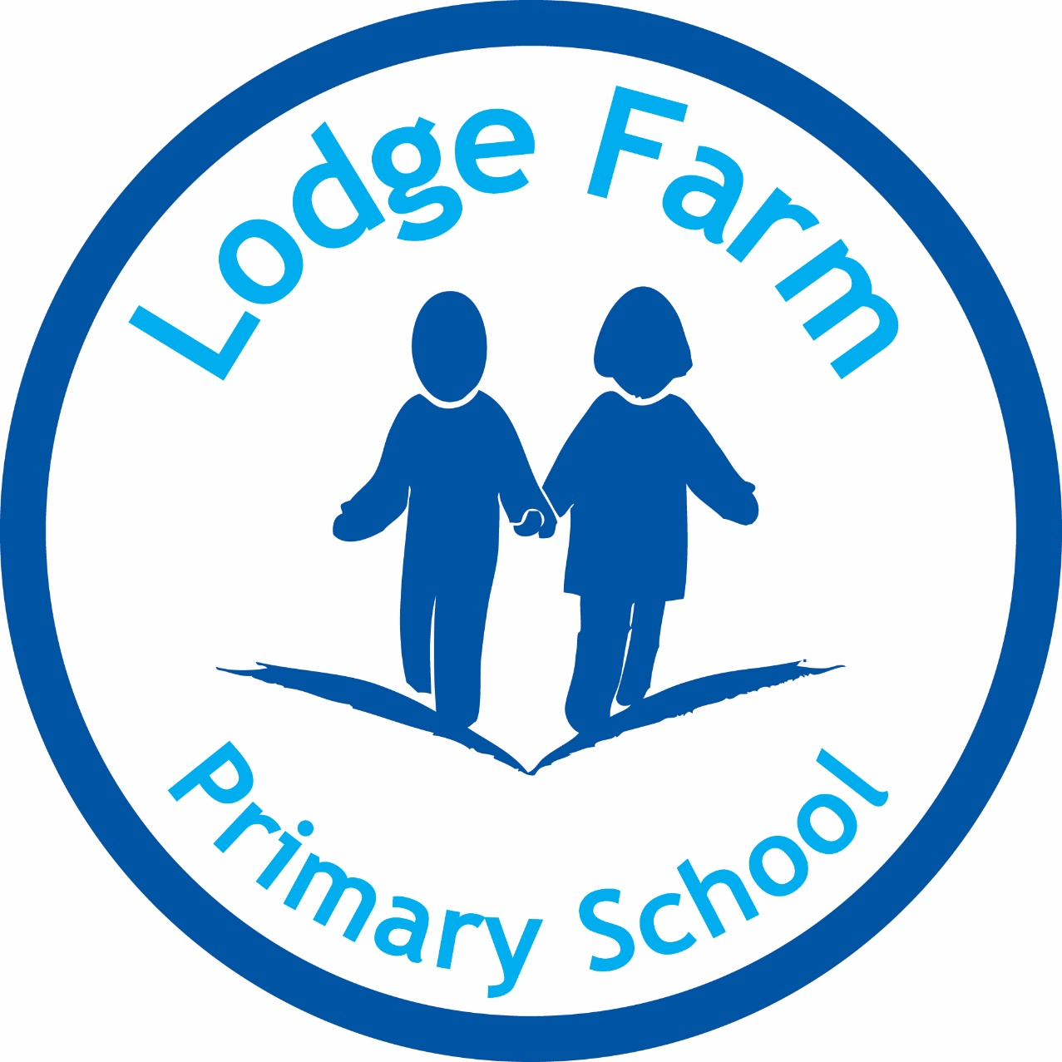

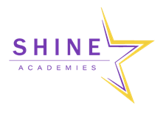

Religious Education Policy
R Barham
2018

Lodge Farm Primary School
RE Policy
School Aims
Lodge Farm Primary School is committed to:
Developing tolerance, understanding and respect for the rights and views of others within our belief in equal opportunities. RE plays an important part in this aim.

Legal Requirement
Religious Education follows the Walsall Agreed Syllabus for RE 2016-2021
It is a core subject of the curriculum for all pupils and according to the Agreed Syllabus is not subject to the flexibility of the Foundation subjects.
The curriculum time allotted to RE is distinct from the time spent on collective worship/assembly.
In line with the law, the Agreed Syllabus expects that schools enable pupils to explore Judaism, Islam, Hinduism, Buddhism and Sikhism, as well as Christianity. It also enables the consideration of secular life stances.

Rationale
RE is an important area in its own right. It contributes to other areas of education and human experience (aesthetic, environmental, ethical, political, social and spiritual). It is an important part of the wider program of spiritual, moral, social and cultural development.
Spiritual – widening pupils’ visions of themselves and their own experience, within the context of growing awareness and understanding of God
Moral – helping pupils to develop their own informed values
Social – helping pupils understand some major issues shaping the values of our society
Cultural - aiding pupils in exploring aspects of their own cultural heritage, and in developing positive attitudes towards diversity

The Nature of RE
The Agreed Syllabus sets the standards expected for pupils’ work. It does this by ensuring all pupils:
- know about and understand a range of religions and world views

- express ideas and insights about the nature, significance and impact of religions and world views

- gain and deploy the skills needed to engage seriously with religions and world views

Religions and Beliefs to be Studied
We will follow the Programme of Study as set out in the Walsall Agreed Syllabus.
The detailed learning programme for EYFS – Y6 can be found on p.26-37.
Aims of RE
The school policy is in line with the aims of the Walsall Agreed Syllabus 2016-2021
- The principle aim is promoting an awareness and understanding of beliefs, practices and experiences of Christianity and other world faiths
- Engaging pupils through learning about religion and learning from religion
- Promoting positive communities, working and living in harmony, ensuring a better future for all

Co-ordinator’s role
- To provide a scheme of work based on the Walsall Agreed Syllabus
- To ensure RE has status within the school
- To keep in touch with developments and disseminate information as appropriate
- To audit and record current resources, supplementing when money is available and informing staff of new resources
- To undertake personal development in the subject
- To monitor provision – planning, classroom practice
- To develop assessment strategies

Current Practice
The spiritual curriculum is recognised in:
- Assembly/collective worship
- Ethos, values and hidden curriculum (SMSC)
- RE curriculum
- Whole school curriculum

Right of withdrawal
Parents have the right to withdraw their children from RE on the grounds that they wish to provide their own religious education. This will be the parents’ responsibility. However, it is good practice to talk to parents to ensure that they understand the aims and value of RE before honouring this right.

Religions and beliefs to be studied by age group are:
To make sure the requirements are met and the curriculum is broad and balanced:
- Christianity should be studied throughout each key stage
- The other major world faiths represented in Great Britain (here regarded as Buddhism, Hinduism, Islam, Judaism and Sikhism) should be studied across the key stages.
- Other religious traditions such as the Baha’i faith, Jainism and Zoroastrianism are recommended
- Secular philosophies such as humanism are recommended

The time allocated for RE in EYFS and KS1 is 36 hours per year and 45 hours per year in KS2.

The following table indicates the current RE topics and in which years they are taught (from SACRE):
 |  | Autumn 1 | Autumn 2 |  | Spring 1 | Spring 2 | Summer 1 | Summer 2
EYFS |  | Special people |  | Special stories | Special places | Special times | Being special | Special world
Year 1/2 | Cycle A (Y2) | Festivals |  |  | Easter |  | Islam | Questions that puzzle
 | Cycle B (Y1) | Celebrating | Being thankful |  | Prayers |  | Sikhs
Year 3/4 | Cycle A (Y4) | Hindu | Muslim: 5 Pillars |  | Journeys |  | Care
 | Cycle B (Y3) | Sacred places |  |  | Holy books | Pilgrimages | Inspirational people: Jesus
Year 5/6 | Cycle A (Y6) | Key leaders | Christians and Humanists |  | Temptation |  | Spiritual Art
 | Cycle B (Y5) | Beliefs and actions around the world |  |  | Commitments and meanings |  | Respect | Inspirational leaders

Assessment
Class teachers must fill in an assessment sheet at least once a term (sometimes half termly) at the end of the topic.
Example of assessment grid:

Class teachers must plan to teach one ‘assessment task’ for every topic – they will use this to assess the children on what they have learned for the topic. Assessment task ideas can be found in SACRE documents.
Example of assessment task:

Adopted by the Governing Body on _________________________________________________________________
Signed by Chair of Governors ______________________________________________________________________
Review date ___________________________________________________________________________________

