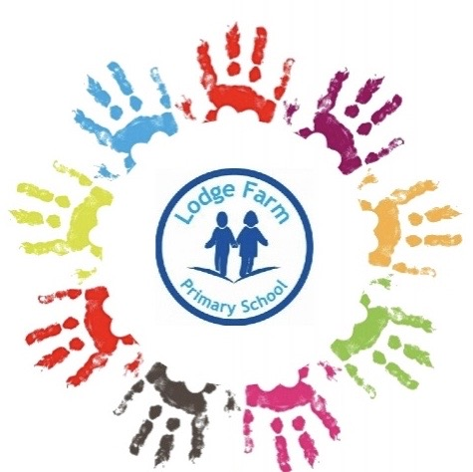

**Lodge Farm Primary Family Liaison Team**

**Autumn Newsletter**

**Meet Our Mental Health First Aiders.**

At Lodge Farm we feel that the mental health and well-being of our parents, children and staff is very important. Below are our mental health first aiders who can offer a listening ear in the safety of the school, while signposting you to services that can help.



Mrs Boys

Mrs Adams

Mrs Jackson

Mr Biddle

Mr Horton



**Mental health and Well- Being**

It is not simply the absence of mental illness, it is a broader indictor to social, emotional, and physical wellness. A range of factors can influence this, including a child or young person's family, community, or school environment. Their physical health and their social and emotional skills.

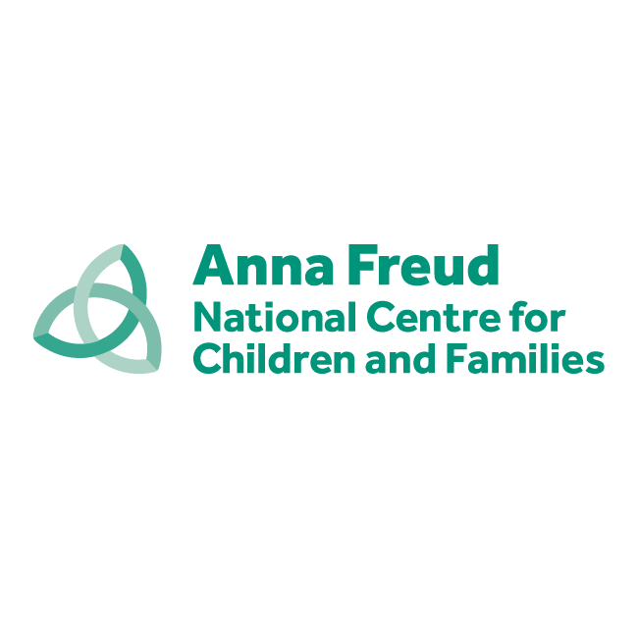

**Anna Freud**

**Anna Freud** National Centre for children and Families is a children’s Charity Dedicated to providing training & Support for children’s mental health services.

**www.annafreud.org**

Other useful Links for Mental Health Support:

Young Minds - <https://youngminds.org.uk>

Barnardos - <https://www.barnardos.org.uk>

Kooth - [www.kooth.com](http://www.kooth.com)

If you have been affected during lockdown, here some other services that can support you and your mental health

Bereavement- Winston’s Wishes

<https://www.winstonswish.org>

Domestic Abuse – Black country Woman’s Aid

<https://blackcountrywomensaid.co.uk>

Financial – Foodbank

<https://bloxwichblakenall.foodbank.org.uk>



postbox@lodgefarmprimary.co.uk

Facebook page

<https://www.facebook.com/LodgeFarm>

Willenhall

Mrs Jackson – 01902 928900

Top Tips:

**Talk about how you are feeling to someone** – Family, Friend, teacher, GP

**Regular Exercise** – walk, swim, jog, gym

**Eat well** - Plenty of fruit and vegetables (avoid alcohol)

**Relax** – Take time out and relax. Listen to music, have a soak in the bath and a good night’s sleep