Handwriting Policy

L Lawson

February 2023

Approved by Chair_________________________

Review Date ______________________________

Handwriting Policy

Intent
Handwriting is a skill which, like reading and spelling, affects written communication across the curriculum. Children must be able to write with ease, speed and legibility. The development of joined handwriting when mastered allows children to apply their energy into the content of their writing as opposed to the formation of the letters themselves. Handwriting skills are taught regularly and systematically throughout the school.

At Lodge Farm Primary School, our aims in teaching handwriting are:
- To enable children to write in a consistent, well presented and legible format.
- To have a consistent approach across the school.
- To make sure all children know the difference between lower and upper case letters.
- To know the importance of clear and neat presentation in order to communicate meaning effectively
- To have a correct pencil grip
- To form all letters correctly
- To know the correct size and orientation of letters

Implementation
At Lodge Farm Primary, we teach letter formation using the Little Wandle formation phrases, which make a link between the mnemonic and the letter. Once children have established letter formation, we use the Nelson Handwriting programme to teach handwriting.
Across the school, handwriting is carefully modelled by the teacher and outcomes are recorded by the children in their English books and handwriting practice books. The use of patterns to support letter formation and appropriate letter-joins (see Appendix 1 for break letters) is also embedded enabling children to also further develop their fine motor skills. High expectations are also communicated as part of the success criteria for the lesson. A high standard of presentation is also encouraged and expected in children’s written work across the wider curriculum.

Knowledge and Skills

Early Years
Children take part in activities to develop their fine and gross motor-skills and recognition of patterns, for example, to form letters using their index finger in sand or using paint. Children should begin to learn how to correctly hold a pencil. Then how to use a pencil and hold it effectively to form recognisable letters most of which are correctly formed. They should be given the opportunities to develop their handwriting to their full potential at that age.

Key Stage 1
Children will continue to develop fine and gross motor skills. Handwriting should be discussed within and linked to phonics sessions. Teachers and support staff continue to guide children on how to write letters correctly, using the correct posture (See Appendix 2) and a comfortable and efficient pencil grip. Children should now be leaving spaces between words accurately. By the end of Key Stage 1, children will be able to write legibly, using upper and lower-case letters appropriately and correct spacing between words using a joined style.

Key Stage 2
During this stage, the children continue to have direct teaching and regular practice of handwriting. We aim for them to develop a clear, fluent style and by the end of Year 6 be able to adapt their handwriting for the for different purposes, such as: a neat, legible hand for finished, presented work, a faster script for note making and the ability to print for labelling diagrams etc.

Provision for left-handed children
At least 10% of the population are left-handed, the majority of whom are boys.
All teachers are aware of the specific needs of left-handed pupils and make appropriate provision:
• paper should be positioned to the left for right handed pupils and to the right for left handed pupils and slanted to suit the individual in either case;
• pencils should not be held too close to the point as this can interrupt pupils’ line of vision;
• pupils should be positioned so that they can place their paper to their left side;
• left-handed pupils should sit to the left of a right-handed child so that they are not competing for space;
• extra practice with left-to-right exercises may well be necessary before pupils write left-to-right automatically.

Teachers are aware of the fact that it is very difficult for left-handed pupils to follow handwriting movements when a right-handed teacher models them.

Impact
Handwriting is a skill which affects written communication across the curriculum. Our aim is that children are able to write with ease, speed and legibility.
By the end of Year 6, children will use joined handwriting using flowing movements and patterns. This handwriting should be demonstrated in all writing across the curriculum. Writing should be fluid in style to allow children to apply their energy into the content of their writing as opposed to the formation of the letters themselves.
Marking and Feedback
We emphasise constructive feedback. In our Marking and Feedback policy, we have clear systems for feedback of children’s work which is adhered to throughout our handwriting sessions. In handwriting sessions and during independent work, it is important that incorrect pencil grip and incorrect letter formation are identified and corrected at the point it occurs.

Equality of opportunity
All of our children have equal access to handwriting lessons and to the resources available. We recognise that some children take longer to develop the necessary skills and we cater for those children by providing additional opportunities for skills development. Children who need specific fine motor or handwriting interventions are identified early and the impact of interventions is carefully monitored. Children with a physical disability are catered for, and progress is monitored, according to their individual action plans.

Monitoring and evaluation
This policy will be reviewed annually by the English Leader.

Appendix 1- Example of break letters and joins

Break Letters

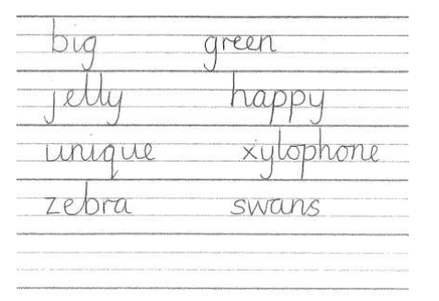

Joins

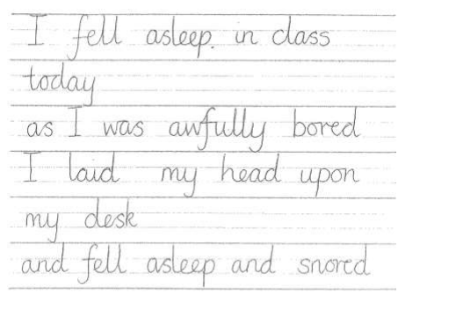

Appendix 2 – Correct posture information

