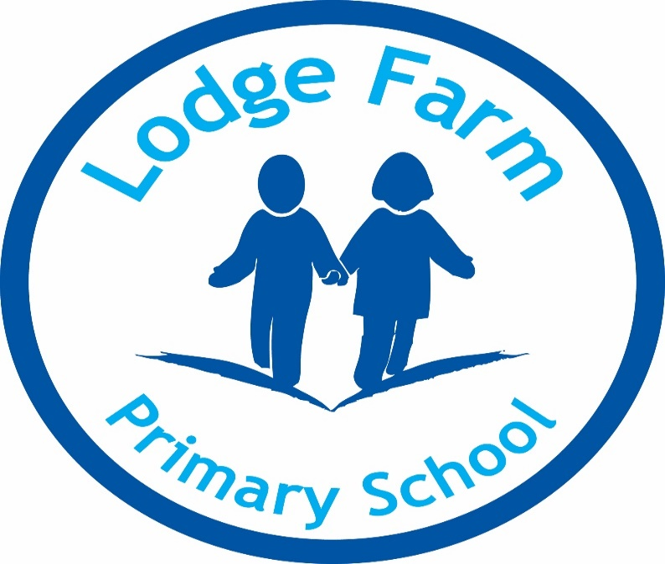
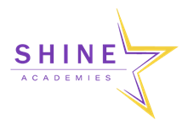

English Policy

L Lawson

December 2022

Approved by Chair________________________

Review Date _____________________________

Intent
It is our intention when teaching the English curriculum that our pupils are provided with a wide range of opportunities to acquire the necessary knowledge, skills and understanding to become lifelong learners and linguists. We strive to ensure that all our pupils receive a well-rounded learning experience when reading, writing, speaking and listening which will equip them with the fundamental tools to achieve in the school and beyond. It is our intention to immerse pupils in the wonders of quality texts to instil a love for reading, a passion for discovery and a confidence to explore their imagination through our curriculum.

English is a core subject of the National Curriculum and a prerequisite for educational and social progress, as it underpins the work undertaken in all areas of the curriculum. The acquisition of language skills is of the upmost importance to us here at Lodge Farm; therefore, the teaching of all aspects English is given a high priority within school. Confidence in basic language skills enables pupils to communicate creatively and imaginatively, preparing them for their future journey through education and beyond.

Our intentions:
- To ensure that every child becomes a reader, a writer and confident speaker by the time they leave Lodge Farm Primary School.
- To promote and inspire a love for reading, writing and high-quality literature into pupils of all ages.
- To derive an English curriculum which is sequenced to develop the acquisition of knowledge and skills and provides the opportunity for these to be embedded.

The key drivers for our curriculum are:
- Aspiration
- Healthy Lifestyle
- Communication
- Knowledge of the World

Statutory Requirements

Statutory requirements for the teaching and learning of English are laid out in the National Curriculum English Document (2014) and in the Communication, Language and Literacy section of the Curriculum Guidance for the Early Years Foundation Stage. (EYFS)

In the Foundation Stage (Nursery and Reception) pupils will be given opportunities to:
• speak and listen and represent ideas in their activities
• use communication, language and literacy in every part of the curriculum
• become immersed in an environment rich in print and possibilities for communication.

At Key Stage One (Years 1 and 2), pupils will:
• learn to speak confidently and listen to what others have to say
• begin to read and write independently and with enthusiasm
• use language to explore their own experiences and imaginary worlds.

At Key Stage Two (Years 3-6), pupils will learn to:
• change the way they speak and write to suit different situations, purposes and audiences
• read a range of texts and respond to different layers of meaning in them
• explore the use of language in literary and non-literary texts
• learn how the structure of language works.

We encourage pupils, from all backgrounds, to be inquisitive and to share their thoughts confidently in a supportive environment. Each child is given the opportunity to acquire the knowledge and skills needed to succeed in an ever literate world.

Implementation
The English Curriculum is delivered using the new updated National Curriculum framework. The Early Learning Goals in EYFS are followed to ensure continuity and progression from the Foundation Stage through to the National Curriculum.

Speaking & Listening
Spoken language underpins the development of reading and writing across the whole curriculum. The quality and variety of language that pupils hear and speak are vital for developing their vocabulary and grammar and their understanding for reading and writing. Pupils develop a capacity to explain their understanding of books and other reading, and to prepare their ideas before they write through talk. They are assisted in making their thinking clear to themselves as well as to others and teachers ensure that pupils build secure foundations by using discussion to probe and remedy their misconceptions. Pupils are taught to understand and use the conventions for discussion and debate as well as taking on different roles in drama.

We encourage all of our pupils to speak/respond in full sentences and speak clearly so others can understand them. Standard English is expected.

Reading
Following the National Curriculum for English, we ensure that Reading is taught across the whole curriculum. Reading comprehension skills are taught with a ‘whole-class’ approach in English.
• We aim for pupils to develop an interest and pleasure in reading as they learn to read confidently and independently based around rich stimulating texts.
• Phonics is taught daily in Early Years and Year 1. (See Phonics and Early Reading policy)
• Reading for pleasure is promoted throughout the school and dedicated time on every class timetable for opportunities for this.
• Reading at home is essential and is recorded using BoomReader for home-school communication.
• Each class visits our school library regularly to exchange, share and discuss books and reading for pleasure; this is also modelled by the class teacher.

Phonics
Skilled word reading involves both the speedy working out of the pronunciation of unfamiliar printed words (decoding) and the speedy recognition of familiar printed words. Underpinning both is the understanding that the letters on the page represent the sounds in spoken words. This is why phonics is emphasised in the early teaching of reading to beginners (i.e. unskilled readers) as they start school.

At Lodge Farm, we follow the ‘Little Wandle Letters and Sound’ programme.

Writing
Following the National Curriculum for English, we ensure that writing is taught across the whole curriculum and we ensure that writing skills are embedded in all forms of writing in all subjects.
• From the very earliest stages of writing development, we promote talk to aid writing.
• Writing is linked to class texts and where possible has a clear purpose/audience for the pupils.
• Writing is modelled throughout the school, by the teacher with a plan, draft, edit, and publish process.
• The use of success criteria are essential for pupils to become independent writers.
• Pupils have access to a range of resources to support their writing and are taught to use these.
• Dictionaries and thesaurus are available for all pupils to use.

Grammar and Punctuation
Grammar and punctuation are a key element of the National Curriculum. These skills are regularly taught within the main English lessons, however are sometimes taught discretely depending on need. We regularly assess pupils’ understanding of grammar taught and how it is embedded in their writing.

Spelling
Spelling is taught in line with the National Curriculum, with all statutory spelling patterns taught in the appropriate age phase and most of the non-statutory work is followed. We follow the Spelling Shed Scheme from Years 2-6. A spelling pattern is focused on in class for at least a week and revisited regularly throughout the scheme. All pupils are exposed to the age-related spelling teaching linked to the national curriculum, however pupils who need additional support may have more personalised spellings to learn each week in line with their needs.

Handwriting
“Writing also depends on fluent, legible and, eventually, speedy handwriting.” National Curriculum 2013

Handwriting lessons begin in Early Years (when pupils have developed fine motor skills) and continue through to Year 6. (See Handwriting Policy)

Impact

Assessment- Attainment targets
By the end of each key stage, pupils are expected to know, apply and understand the matters, skills and processes specified in the relevant programme of study. (See National Curriculum)

End of unit assessments
• From Year 2 to Year 6, pupils complete termly NFER assessments in Grammar, Punctuation and Spelling and Reading in Years 3, 4 and 5. Years 2 and 6 use past SATs paper for practice.
• Year 2 complete a phonic screening check at the end of Autumn for those pupils who did not meet the threshold in Year 1 to ensure the interventions and teaching are meeting needs and improving skills and knowledge and to plan further intervention.
• Year group work together to analyse all assessments completed to identify gaps in learning and provision and to ensure this is in place for the next half term of planning.
• Class teachers assess writing using an assessment sheet of National Curriculum objectives and use any gaps to inform target setting for the following half term.

Statutory Assessments
• EYFS baseline assessments
• Year 1 Phonics Screening Check
• KS2 National Curriculum Tests and Teacher Assessments (Year 6)

Data
All teachers are responsible for keeping accurate records of attainment and progress made in line with the Assessment policy.

Marking
Teachers mark pupils’ writing throughout the lesson to ensure that errors and misconceptions are addressed as soon as possible, rather than a pupil complete a whole piece of writing incorrectly. Handwriting formation, size and spellings are also corrected as issues arise, with pupils given the opportunity to practise during the lesson.
Please refer to our Marking Policy for further guidance on marking.

Cross-curricular English Opportunities
Teachers will seek to take advantage of opportunities to make cross-curricular links. They will plan for pupils to practise and apply the skills, knowledge and understanding acquired through English lessons to other areas of the curriculum.

The role of the class teacher:
• to ensure progression in the acquisition of mathematical skills with due regard to the National Curriculum 2014 and the school’s English policy
• to develop and update skills, knowledge and understanding for reading and writing
• to identify misconceptions and gaps in leaning and plan intervention strategies to address them
• to keep appropriate on-going records
• to plan effectively for English, liaising with the subject leader when necessary.
• to inform parents of pupils’ progress, achievements and attainment.

The role of the subject leader:
• ensuring continuity and progression from year group to year group
• advising on in-service training to staff where appropriate.
• advising and supporting colleagues in the implementation and assessment of reading and writing throughout the school.

Spiritual, moral, social and cultural development

Spiritual development: In responding to a poem, story or text; pupils can be asked ‘I wonder what you wonder?’ ‘How would you feel if you were the person in the story?’ ‘Where have you met these ideas before?’e.g., when responding to text through drama or Real Reading thinking stems. By appreciating the beauty of language, e.g., poetic language within stories and poems.

Moral development: By exploring stimulus for thinking about the consequences of right and wrong behaviour; pupils can speculate and apply their learning to their own lives. When they do this they are developing their speaking, listening and higher order thinking skills. E.g., The Iron Man. By considering different perspectives and showing empathy.

Social development: By supporting conceptual and language development through an understanding of and debates about social issues, e.g., the destruction of the rainforest. Work collaboratively, e.g., as part of a dramatised response; to prepare a verbal response to an argument; to evaluate each others’ work. By providing opportunities for talk in a range of settings, to a range of audiences and for different purposes. E.g., assemblies, performances and structured discussion.

Cultural development: By providing opportunities for pupils to engage with texts from or representing different cultures. By providing opportunities for pupils to visit the theatre and experience theatrical productions.

Inclusion
We aim to provide for all pupils so that they achieve as highly as they can in English and aspire to be their best according to their individual abilities. We will identify which pupils or groups of pupils are under-achieving and take steps to improve their attainment. More able pupils will be identified and suitable learning challenges provided.

Equal Opportunities
All pupils are provided with equal access to the English curriculum. We aim to provide suitable learning opportunities regardless of gender, ethnicity or home background. We expect all pupils to be equipped with the English knowledge and skills they need to succeed in life.

This policy will be reviewed annually.

