Calculation Policy
December 2022
R.Horton

This policy supports the White Rose maths scheme used throughout the school. Progression within each area of calculation is in line with the programme of study in the 2014 National Curriculum. This calculation policy should be used to support children to develop a deep understanding of number and calculation. This policy has been designed to teach children through the use of concrete, pictorial and abstract representations.
• Concrete representation— a pupil is first introduced to an idea or skill by acting it out with real objects. This is a ‘hands on’ component using real objects and is a foundation for conceptual understanding.
• Pictorial representation – a pupil has sufficiently understood the ‘hands on’ experiences performed and can now relate them to representations, such as a diagram or picture of the problem.
• Abstract representation—a pupil is now capable of representing problems by using mathematical notation, for example 12 x 2 = 24. It is important that conceptual understanding, supported by the use of representation, is secure for all procedures. Reinforcement is achieved by going back and forth between these representations.
Mathematics Mastery
At the centre of the mastery approach to the teaching of mathematics is the belief that all children have the potential to succeed. They should have access to the same curriculum content and, rather than being extended with new learning, they should deepen their conceptual understanding by tackling challenging and varied problems. Similarly, with calculation strategies, children must not simply rote learn procedures but demonstrate their understanding of these procedures through the use of concrete materials and pictorial representations.
This policy outlines the different calculation strategies that should be taught and used in Year 1 to Year 6 in line with the requirements of the 2014 Primary National Curriculum.
How to use the policy:
This mathematics policy is a guide for all staff at Lodge Farm Primary School and has been adapted from work by the NCETM. All teachers have been given the scheme of work from the White Rose Maths Hub and are required to base their planning around their year group’s modules and not to move onto a higher year group’s scheme work. These modules use the Singapore Maths Methods and are affiliated to the workings of the 2014 Maths Programme of Study. Teachers can use any teaching resources that they wish to use and the policy does not recommend one set of resources over another, rather that, a variety of resources are used. For each of the four rules of number, different strategies are laid out, together with examples of what concrete materials can be used and how, along with suggested pictorial representations. The principle of the concrete-pictorial-abstract (CPA) approach [Make it, Draw it, Write it] is for children to have a true understanding of a mathematical concept, they need to master all three phases within a year group’s scheme of work.
Reasoning and Problem Solving
Each lesson, children are exposed to reasoning and problem solving questions to embed their understanding of the skills gained within the lesson. They use their learning in real-life contexts to solve complex and abstract problems, considering skills gained in previous areas of learning.

Nursery – addition
Progression of calculation | Concrete | Pictorial | Abstract
O+O – combining objects  1 more than a given number up to 5.  O+O –counting on from a given number.  - Subitise to 5 - Automatically recall number bonds to 5 - React to changes in an amount up to 3 items – adding items - Understand when two groups are the same - Solve real world mathematical problems up to 5  - Be able to express how many there are in total through knowing that the last number counted is the total ‘cardinal principle’.  - Use key vocabulary when explaining reasoning ‘I think this is larger because….’ I think they have more because…’ | 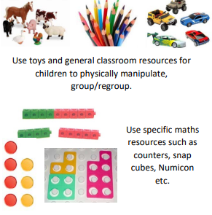 | 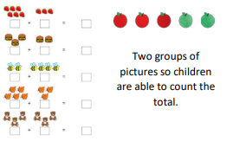 | 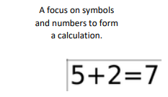  Link the calculation to concrete and pictorial examples underneath the calculation.  *It is an introduction to the calculation. Children must be secure with what a number “ looks like” in the concrete example.  *No expectation for children to record a number calculation.
Language | Add More And + Total Make Sum Lots Same Larger Smaller
Resources | Numicon real life objects to count cubes and mathematical counting equipment.

Reception addition
Progression of calculation | Concrete | Pictorial | Abstract
Understanding of the principle – the final number counted is the total.  Subitise and then use counting to check (up to 10).  O+O – combining objects 1 more than a given number up to 20.  O+O –counting on from a given number.  Compare numbers using language such as ‘more than’ and ‘greater than’ and have a good understanding of ‘one more than’.  Understand the composition of numbers to 10. Begin with numbers to 5 and understand the number bonds using a range of resources and physical objects, encouraging subitising.  Move on to larger numbers as children develop a secure understanding.  Be able to recall number bonds to 10.  Use opportunities to encourage children to recall number bonds e.g. ‘there are 3 children on the carpet and 3 children at the table. There are 6 children.’  Solve problems using concrete resources and pictorial images. Children develop ways of recording calculations using numicon, bead strings, counters, part whole models, marks etc. | 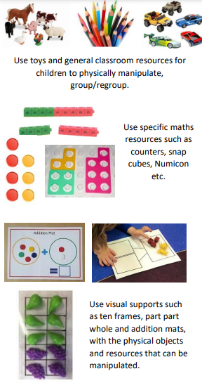 | 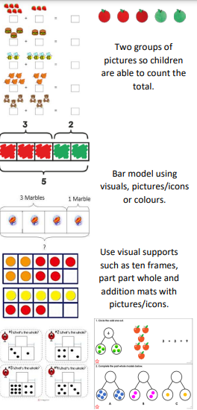 | 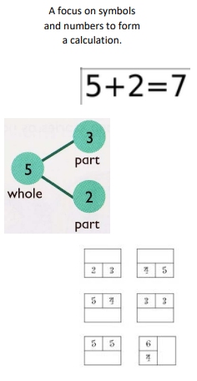
Language | Add More And + Total Make Sum Sequence
Resources | Numicon Counting Equipment Bead Strings Number lines

Year 1 addition
Progression of calculation | Concrete | Pictorial | Abstract
O+O counting on  O+O crossing 10  O+O crossing 10 using number facts to bridge  TO + O within 20  O + multiple of 10  1 more than any give number to 100  - Confidently subitise numbers to 10 using knowledge from EYFS  - Addition and subtraction to be taught alongside each other so that children can see the relationship between the two.  - Derive additive facts to 10. E.g. “I know that 3 + 3 = 6 so 3 + 4 = 7”  - Learn to recognise odd and even numbers using concrete resources.  - Understand the equals sign as a ‘balance’.  - Combining two parts to make a whole: part whole model.  - Joining two groups and then recounting all objects (number bonds within 10). | 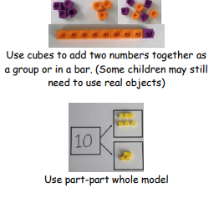  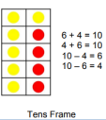  (Some children may need to initially use real objects then move onto the representation, egg boxes may also be used to support this)  Start at the bigger number and counting on  Start with the larger number on the bead string and then count of to the smaller number 1 by 1 to find the answer.  Regrouping to make 10 (The ‘Make 10’ strategy)  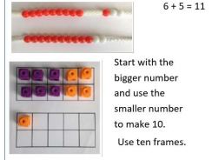 | 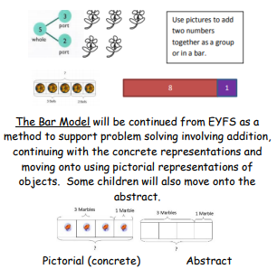  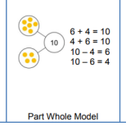  Start at the bigger number and counting on  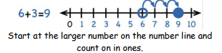  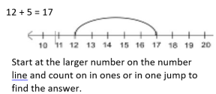  Regrouping to make 10 (The ‘Make 10’ strategy)  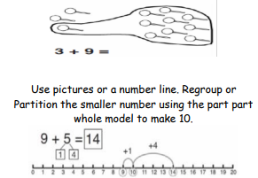  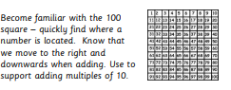 | 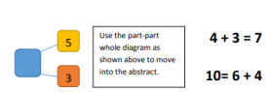  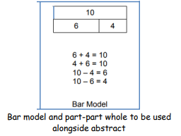  Start at the bigger number and counting on  Place the larger number in your head and count on the smaller number to find your answer.  Regrouping to make 10 (The ‘Make 10’ strategy)  7 + 4= 11  If I am at seven, how many more do I need to make 10. How many more do I add on now?
Language | add, more, plus, and, make, altogether, total, equal to, equals, double, most, count on, number line, balancing, part, part, whole
Resources | Numicon Hundred Square Bead Strings Straws Number lines Tens frame Counting equipment Double sided counters

Year 2 addition
Progression of calculation | Concrete | Pictorial | Abstract
TO+O (not crossing 10)  TO+T (not crossing 10)  TO+O (bridging through 10)  TO + ‘teens number’  TO+TO (not crossing tens)  O+O+O  - Understand addition as commutative.  - Use the bar model to find missing digits.  - Use the inverse to find missing numbers.  - Confidence with a strategy to add/subtract, in particular when bridging ten.  - Use additive facts to connect numbers e.g. 3 + 4 = 7 so 30 + 40 = 70, moving onto recognising 35 + 40 = 75  - Recognise all coins and use this to add to an amount. | 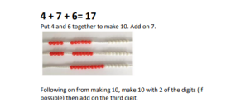  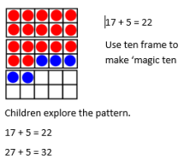  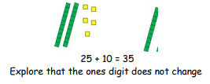  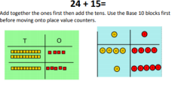 | 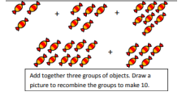  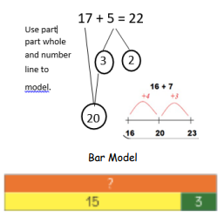  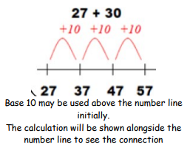  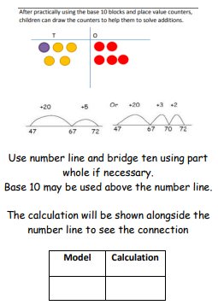 | 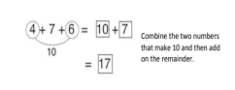  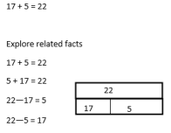  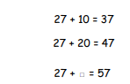  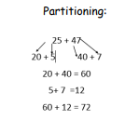
Language | Partition Equals/Same as Addition Number bonds More than Missing number Total/Sum Inverse Commutative Calculate Strategy Addend
Resources | Numicon Base 10 Bead Strings Arrow cards Number lines Hundred Square Counting equipment

Addition Year 3
Progression of calculation | Concrete | Pictorial | Abstract
TO+TO (bridging through 10s, not crossing 100)  TO+TO  HTO+TO  HTO+HTO  - Know and use complements to 100, especially when calculating money problems and finding change.  - Recognise the inverse and use to check calculations | 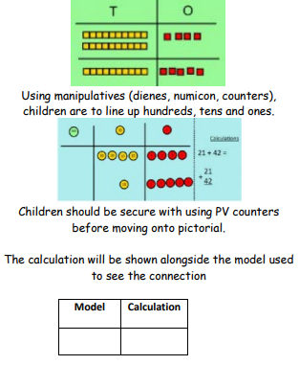  *  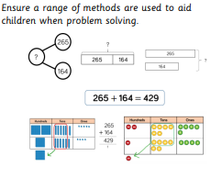 | 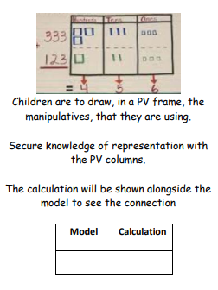  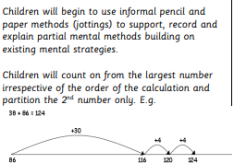  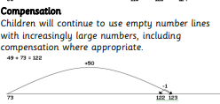 | 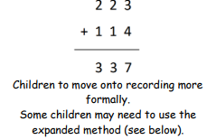
Language | All previous words  Increase – get larger  Addend – a number to be added to another  Augmentation – increase a quantity or measure by another quantity.  Commutative – numbers can be added in any order.  Complement – in addition, a number and its complement make a total Exchange – change a number for another of an equal value.  Partitioning – split a number into parts.  Subitise – instantly recognise the number of objects in a small group.  Sum – the result of an addition  Total – the aggregate or the sum found by addition.  Ones/Tenths/Hundreds Boundary – The boundary to the next PV column – knowing when to exchange.  Inverse – the opposite in effect
Resources | Diennes/Base 10 ,Arrow Cards, Part Whole Model, Bar Model , Cubes , Tens Frames, Bead Strings, Number Tracks/Number Lines/Empty number line, Place value counters/Place value grid/Place Value Sliders, Tens frame (scaling known facts)

Addition year 4
Progression of calculation | Concrete | Pictorial | Abstract
HTO+HTO (Crossing 100)  £O.t h + £O. t h  £TO.t h + £TO. t h  - Scaling number facts by 100 and using known additive facts to solve calculations.  Children may continue to use the number line to count on and support mental calculations. Expanded Method to Compact Method  Children will use various place value resources to support the development of conceptual understanding of a formal written method. Children now learn to carry below the line using resources to support understanding. | 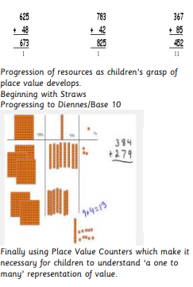  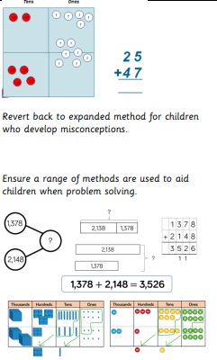  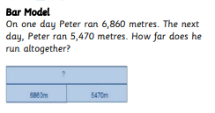 | 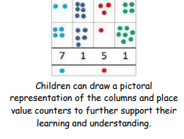 | 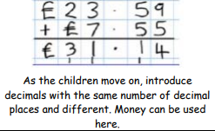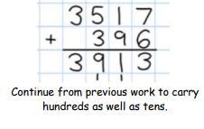
Language | All previous words  Exchange – change a number for another of an equal value. Partitioning – split a number into parts.  Decimal point
Resources | Diennes/Base 10 ,Arrow Cards, Part Whole Model, Bar Model , Cubes , Tens Frames, Bead Strings, Number Tracks/Number Lines/Empty number line, Place value counters/Place value grid/Place Value Sliders, Tens frame (scaling known facts)

Addition Year 5
Progression of calculation | Concrete | Pictorial | Abstract
Addition of numbers beyond 1000s  - Addition of numbers with up to three decimal places.  - Addition of numbers with up to 4 digits and decimals with various missing place-holders.  - Using a bar model to find missing amounts and to support problem solving.  - Scale known additive facts, both within 10 and bridging 10 when adding/subtracting decimals. E.g. 0.5 + 0.4 = 0.9 or 0.8 + 0.6 = 1.4  Also use this knowledge with complements to 100  - scale to complements to 1.  E.g. 73 + 27 = 100 so 0.73 + 0.27 = 1 Children to continue to demonstrate understanding of mental methods.  Children to recognise when to use a mental or a written method. | See Year 4 | See Year 4 | 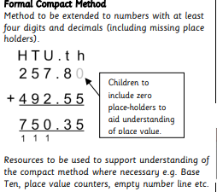  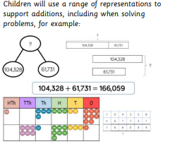
Language | As above
Resources | Place value counters Base Ten Calculation Mat Empty Number Line Arrow Cards Place value grid Place Value Sliders Bar Models Tens frame (scaling known facts)

Addition Year 6
Progression of calculation | Concrete | Pictorial | Abstract
Addition of numbers with any number of digits.  - Addition of two or more numbers with up to 3 decimal places (including problems involving money).  - Addition of two or more numbers with at least 4 digits of various sizes and varied decimal places.  (E.g. 401.2 + 26.85 + 13 =)  - Using the bar model to support addition and problem solve.  - Use a given additive calculation to derive or complete a related calculation, using arithmetic and place value knowledge and inverse operations.  Children will continue to develop procedural fluency of the column method. | 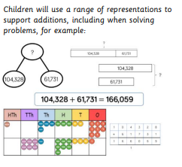  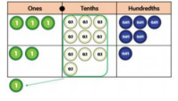 | See Year 4 | 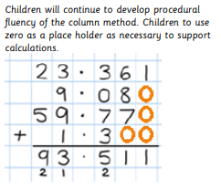
Language | As above
Resources | Place value counters Base Ten Calculation Mat Empty Number Line Arrow Cards Place value grid Place Value Sliders Bar Models

Subtraction Nursery
Progression of calculation | Concrete | Pictorial | Abstract
O-O (take –away)  1 less than a given number up to 5  O-O (comparison e.g. – ‘how many more…’; ‘how many less…’)  - React to changes in an amount up to 3 items  – taking away items  - Join in with songs and nursery rhymes involving hiding/returning# – e.g. 5 little ducks  - Solve real world mathematical problems up to 5  - Use key vocabulary when explaining reasoning ‘this person has fewer because…’ | 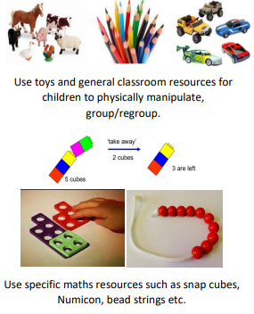 | 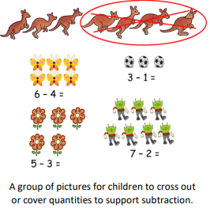 | 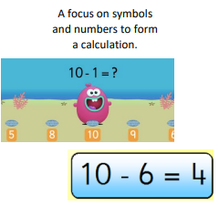
Language | Take Away Less Left Over Fewer Difference Between equal to/equals -
Resources | Real life objects cubes counters and mathematical counting equipment.

Subtraction EYFS
Progression of calculation | Concrete | Pictorial | Abstract
O-O (take –away) 1 less than a given number up to 20.  O-O (comparison e.g. – ‘how many more…’; ‘how many less…’) Compare numbers using language such as ‘less than’ and ‘fewer than’ and have a good understanding of ‘one less than’. Understanding of numbers to 10 and link this knowledge to subtraction. Begin with numbers to 5 and understand the number bonds using a range of resources and physical objects, encouraging subitising. Move on to larger numbers as children develop a secure understanding. Be able to recall number bonds to 10. Use opportunities to encourage children to recall number bonds e.g. ‘there were 5 children on the carpet but 2 have gone to play. There are now 3 children.’ Use touch counting to understand the concept of subtraction, encouraging the children to physically take concrete resources away. | 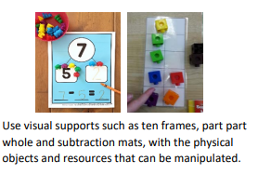 | Children use number lines, tracks and numicon shapes to find one less and to support with counting back. Teachers demonstrate the use of the number line.  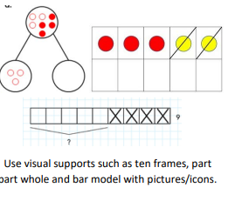 | 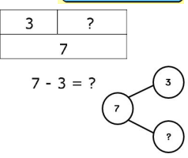
Language | Take Away Less Left Over Fewer Difference Between equal to/equals -
Resources | Real life objects cubes counters and mathematical counting equipment.

Subtraction Year 1
Progression of calculation | Concrete | Pictorial | Abstract
O-O (take-away)  O –O (comparison and difference)  - Any subtraction from 20 -Derive and use additive facts and make connections between these and subtraction problems.  - Subtract multiples of 10 using the vocabulary ‘one ten, two tens, three tens’ alongside 10, 20, 30.  - Addition and subtraction to be taught alongside each other so that children can see the relationship between the two.  - Subtract using Base Ten/straws and understand regrouping one ten for ten ones. | Taking away  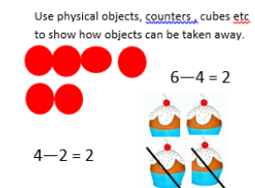  Counting back  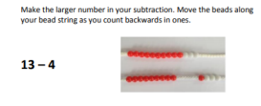  Finding the difference  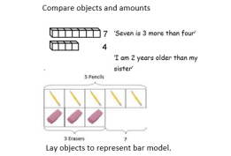  Number bonds and related subtraction facts to 20  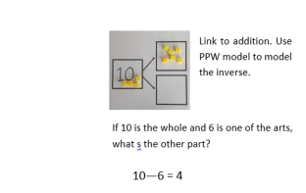 | 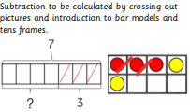  Taking away  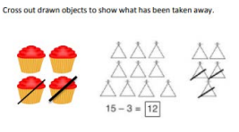  Counting back  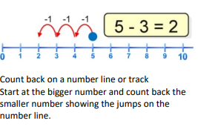  Finding the difference  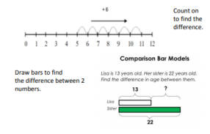  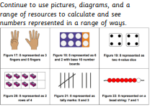  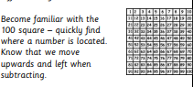 | 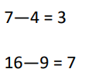  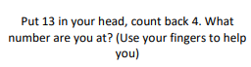  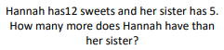  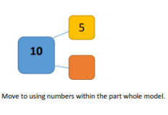
Language | equal to, take, take-away, less, minus, subtract, leaves, distance between, how many more, how many fewer/less than, most, least count back, how many left, how much less is…
Resources | Bead Strings Tens frame Number lines Straws Counting equipment Double sided counters Hundred Square Numicon

Subtraction Year 2
Progression of calculation | Concrete | Pictorial | Abstract
O-O (not crossing 10s)  TO-O (crossing 10s)  TO-T  TO-TO (counting back)  TO-TO (counting on)  - Recognise that subtraction is not commutative.  - Recognise the inverse and use to check calculations using bar models. | 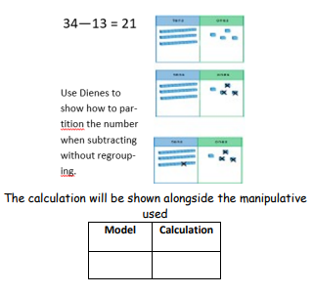 | 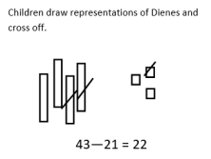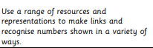  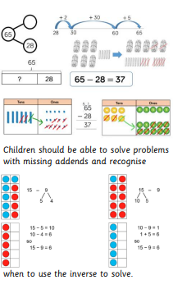  Recognise the inverse and use bar models to check  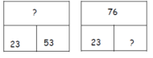 | Where children are able begin to use the column method ( ensure children have a secure knowledge of place value prior to teaching)
Language | equal to, take, take-away, less, minus, subtract, leaves, distance between, how many more, how many fewer/less than, most, least count back, how many left, how much less is… , Subtraction, Fewer ,Difference Between Equal to/Equals, Addend How many more
Resources | Bead Strings Tens frame Number lines Straws Counting equipment Double sided counters Hundred Square Numicon
Subtraction Year 3
Progression of calculation | Concrete | Pictorial | Abstract
Empty Number Line  HTO-TO (crossing100s)  HTO-HTO  Expanded Column Method  HTO-HTO Stage 1 : no exchange Stage 2: Exchange T to O  Stage 3: Exchange H to T - Recognise the inverse and use to check calculations | 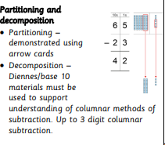  NOTE - When solving the calculation 89 – 57, children should know that 57 DOES NOT EXIST AS AN AMOUNT it is what you are subtracting from the other number. Therefore, when using base 10 materials, children would need to count out only the 89. | 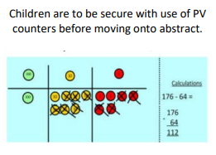  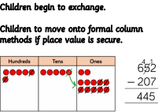 | 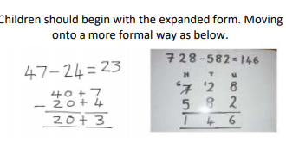
Language | All previous words  Decrease – get smaller  Difference – the numerical difference between two numbers found by comparing each quantity  Exchange – change a number or expression for another of equal value  Minuend – a quantity or number from which another is subtracted  Partitioning – splitting a number into parts  Reduction – subtraction as take away Subtrahend – a number  subtracted from another Inverse – the opposite in effect
Resources | Bead Strings Tens frame Number lines Straws Counting equipment Double sided counters Hundred Square

Subtraction Year 4
Progression of calculation | Concrete | Pictorial | Abstract
HTO+HTO (Crossing 100)  £O.t h + £O. t h £TO.t h + £TO. t h - Scaling number facts by 100 and using known additive facts to solve calculations.  Children may continue to use the number line to count on and support mental calculations. Expanded Method to Compact Method  Children will use various place value resources to support the development of conceptual understanding of a formal written method.  Children now learn to carry below the line using resources to support understanding. | Children to use dienes and then PV counters.  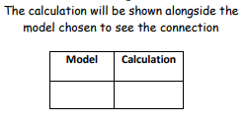 | 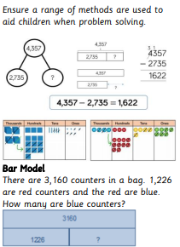  Children to draw dienes and then PV counters. | 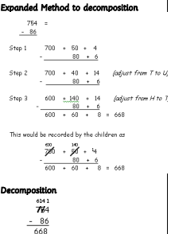
Language | Decrease – get smaller Difference – the numerical difference between two numbers found by comparing each quantity  Exchange – change a number or expression for another of equal value  Minuend – a quantity or number from which another is subtracted  Partitioning – splitting a number into parts  Reduction – subtraction as take away  Subtrahend – a number subtracted from another  Inverse – the opposite in effect.
Resources | Straws Diennes/Base 10/Big Base Calculation Mat Arrow Cards Part-Whole Model Bar Model Number Shapes (Numicon) Cubes Tens Frames Bead Strings Number Tracks/Number Lines/Empty number line Place value counters/Place value grid/Place Value Sliders Double sided counters Bar Models

Subtraction Year 5
Progression of calculation | Concrete | Pictorial | Abstract
Subtract at least 4 digit numbers and up to 3 decimal places.  - Larger numbers involving decimals including money and measures.  - Use bar models to support subtraction.  - Scale known additive facts, both within 10 and bridging 10 when adding/subtracting decimals.  E.g. 0.9 - 0.5 = 0.4 and 1.5 – 0.6 = 0.9 | See year 4 | 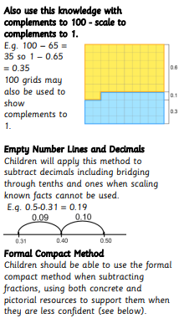  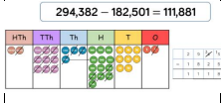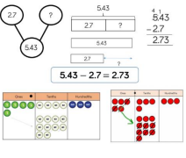 | 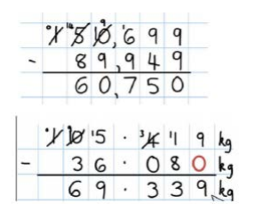
Language | All previous words  Decrease – get smaller  Difference – the numerical difference between two numbers found by comparing each quantity  Exchange – change a number or expression for another of equal value  Minuend – a quantity or number from which another is subtracted  Partitioning – splitting a number into parts  Reduction – subtraction as take away  Subtrahend – a number  subtracted from another Inverse – the opposite in effect
Resources | Double sided counters Place value counters Base Ten Calculation Mat Empty Number Line Arrow Cards Place value grid Place Value Sliders Bar Models

Subtraction Year 6
Progression of calculation | Concrete | Pictorial | Abstract
Refine Year 5  Subtracting with increasingly more complex numbers with up to 3 decimal places (including problems involving money). Using the bar model to support subtraction. Difference between two negative integers. Difference between positive and negative integers. | See year 4 | 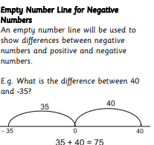 | 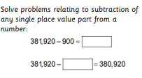  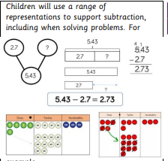
Language | All previous words  Decrease – get smaller  Difference – the numerical difference between two numbers found by comparing each quantity  Exchange – change a number or expression for another of equal value  Minuend – a quantity or number from which another is subtracted  Partitioning – splitting a number into parts  Reduction – subtraction as take away  Subtrahend – a number  subtracted from another Inverse – the opposite in effect
Resources | Double sided counters Place value counters Base Ten Calculation Mat Empty Number Line Arrow Cards Place value grid Place Value Sliders Bar Models

Multiplication Nursery
Progression of calculation | Concrete | Pictorial | Abstract
Experiment with numbers up to 10, looking at equal groups supported by the teacher | 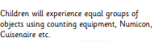 | 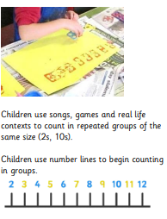 | NA
Language | Same
Resources | Real life objects, sorting equipment

Multiplication EYFS
Progression of calculation | Concrete | Pictorial | Abstract
Counting in 2s and 10s  Beginning to double single-digit numbers.  Become exposed to language such as ‘double’ and ‘half’ and see this using concrete resources. | 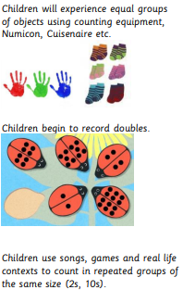 | 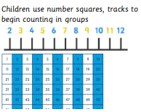  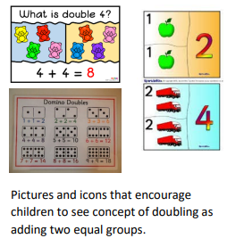 | 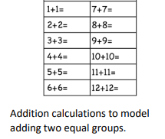
Language | Same , double , half
Resources | Real life objects, sorting equipment , counters ,number lines, double bugs, number squares

Multiplication Year 1
Progression of calculation | Concrete | Pictorial | Abstract
Doubling of numbers to 10  - Counting in 2s, 5s and 10s from 0 - When moving to pictorial/written calculations, language is vital.  - Repeated addition as a method to solve multiplication problems  - Learn to recognise 2p, 5p and 10p coins and apply their knowledge of multiples when using these.  E.g. calculating how many coins to give to pay for an item.  - Count in tens to add and subtract (see addition and subtraction).  They will count in 2s and 10s and begin to count in 5s mentally, using a number line to count jumps, using sets of counters | 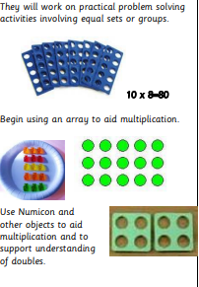 | 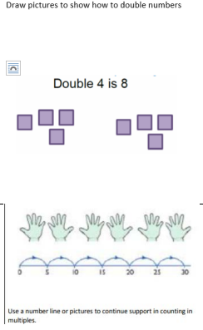  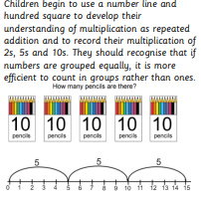 | 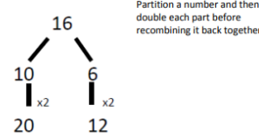  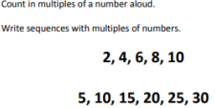  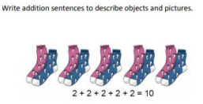  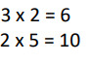
Language | Multiplication Groups of Equal Multiply Lots of Multiplied by Sets of Multiple Array
Resources | Real life objects, sorting equipment , counters ,number lines, double bugs, number squares, arrays, straws

Multiplication Year 2
Progression of calculation | Concrete | Pictorial | Abstract
x 2, 5 and 10  Doubles up to 20+20  - Introduction to the X symbol and use when writing formal calculations.  - Recall and reuse facts from times tables, recognising when to use these in problems.  - Understand that multiplication is commutative.  - Consider introducing counting in 3s towards the end of the year | Multiplication is commutative  Create arrays using a range of equipment  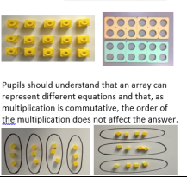  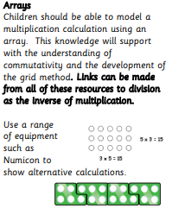  Repeated addition can be shown on a bead string.  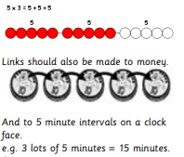 | 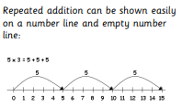  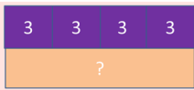  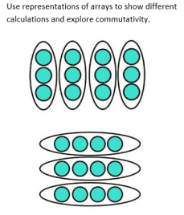  Number facts  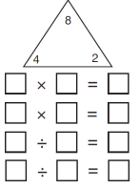 | *Please note the aim is for the children to express multiplication in a range of ways:  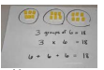  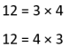  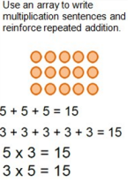
Language | Multiplication Groups of Equal Multiply Lots of Multiplied by Sets of Multiple Array row Column Multiplication Table Times Repeated addition
Resources | Real life objects, sorting equipment , counters ,number lines, double bugs, number squares, arrays, straws, clocks, money

Multiplication Year 3
Progression of calculation | Concrete | Pictorial | Abstract
Ox (2,3,4,5,8,10)  (1-20) x (2,3,4,5,8,10)  – beyond 20 when confident. Multiply 1 or 2 digit numbers by 10 and 100.  - Understand the commutative property of multiplication  Children will continue to use: Repeated Addition 4 times 6 is 6 + 6 + 6 + 6 = 24 or 4 lots of 6 or 6 x 4 | Children should continue to use bead strings to support their understanding of multiplication as repeated addition | Children should continue to use number lines to support their understanding of multiplication as repeated addition  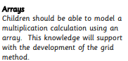  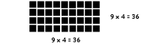  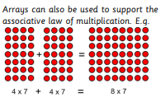  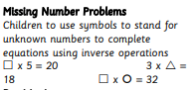  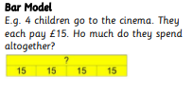 | 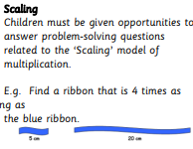  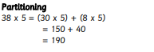
Language | All previous words  Factorise – finding what to multiply to get an expression. Array – an ordered collection of resources in rows and columns.  Commutative – numbers that can be multiplied in any order.  Exchange – change a number for another of an equal value.  Factor – a number that multiplies with another to make a product. Multiplicand – a number to be multiplied by another.  Partitioning – splitting a number into parts.  Product – the result of multiplying one number by another.  Scaling – enlarging or reducing a number by a given amount.  Inverse – the opposite in effect.
Resources | Counters Multiplication Squares Bead Strings Empty Number Line Number Tracks/Number Lines Place Value Counters/ Place value grid/Place Value Calculation Mat Place Value Sliders Bar Models base 10

Multiplication Year 4
Progression of calculation | Concrete | Pictorial | Abstract
O x TO  O x HTO Multiplication of numbers by 10,100 and 1000. Knowledge of all multiplication facts up to 12x12.  - Secure understanding of the commutative property of multiplication.  Multiply 2-digit numbers by 1-digit numbers  Multiply 3-digit numbers by 1-digit numbers | 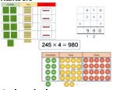  Children to use arrays if needed to support the grid method.  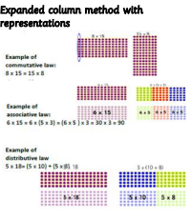 | 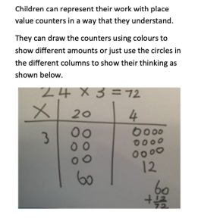  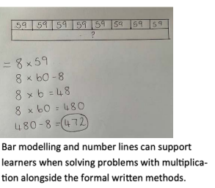 | 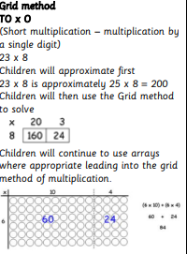  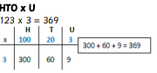  The grid method should lead into the column method  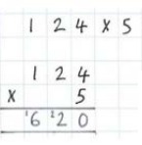
Language | All previous words  Factorise – finding what to multiply to get an expression. Array – an ordered collection of resources in rows and columns.  Commutative – numbers that can be multiplied in any order.  Exchange – change a number for another of an equal value.  Factor – a number that multiplies with another to make a product. Multiplicand – a number to be multiplied by another.  Partitioning – splitting a number into parts.  Product – the result of multiplying one number by another.  Scaling – enlarging or reducing a number by a given amount.  Inverse – the opposite in effect.
Resources | Counters Multiplication Squares Bead Strings Empty Number Line Number Tracks/Number Lines Place Value Counters/ Place value grid/Place Value Calculation Mat Place Value Sliders Bar Models base 10

Multiplication Year 5
Progression of calculation | Concrete | Pictorial | Abstract
ThHTO x O  - HTO x O  - TO x TO  - Use a bar model to support problem solving in multiplication. - Multiply by 10, 100 and 1000 and understand how this affects a number’s place value.  Area Model | 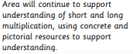  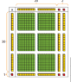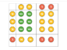  If children are struggling with their times tables knowledge, offer a multiplication grid so that they can focus on the method |  | 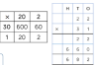  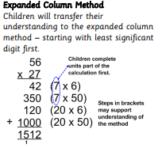  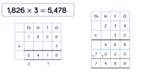
Language | All previous words  Factorise – finding what to multiply to get an expression. Array – an ordered collection of resources in rows and columns.  Commutative – numbers that can be multiplied in any order.  Exchange – change a number for another of an equal value.  Factor – a number that multiplies with another to make a product. Multiplicand – a number to be multiplied by another.  Partitioning – splitting a number into parts.  Product – the result of multiplying one number by another.  Scaling – enlarging or reducing a number by a given amount.  Inverse – the opposite in effect.
Resources | Counters Multiplication Squares Bead Strings Empty Number Line Number Tracks/Number Lines Place Value Counters/ Place value grid/Place Value Calculation Mat Place Value Sliders Bar Models base 10 multiplication grids

Multiplication Year 6
Progression of calculation | Concrete | Pictorial | Abstract
TH H T O x O  H T O x T O  O x O. t h  Multiply by up to 2 decimal places. Understand the relationship between powers of 10 and apply this.  Use bar models to support multiplication. Use a given multiplicative calculation to derive or complete a related calculation, using arithmetic and place value knowledge and inverse operations. | 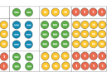 | Children may continue to use the area model as necessary to maintain understanding of place value when multiplying larger numbers and understanding the process of finding partial products. Move understanding to column method as soon as secure.  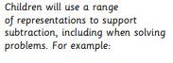 | 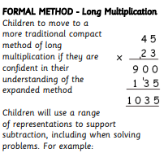  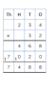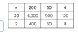  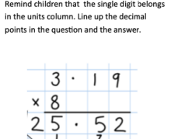
Language | All previous words  Factorise – finding what to multiply to get an expression. Array – an ordered collection of resources in rows and columns.  Commutative – numbers that can be multiplied in any order.  Exchange – change a number for another of an equal value.  Factor – a number that multiplies with another to make a product. Multiplicand – a number to be multiplied by another.  Partitioning – splitting a number into parts.  Product – the result of multiplying one number by another.  Scaling – enlarging or reducing a number by a given amount.  Inverse – the opposite in effect.
Resources | Counters Multiplication Squares Empty Number Line Number Tracks/Number Lines Place Value Counters/ Place value grid/Place Value Calculation Mat Place Value Sliders Bar Models

Division Nursery
Progression of calculation | Concrete | Pictorial | Abstract
Begin to share and understand the basic concept ‘one for me, one for you’ Children will understand equal groups and share items out in play and problem solving. | Explore sharing groups with real life items  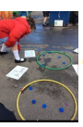
Language | Share
Resources | sorting equipment and real life items

Division EYFS
Progression of calculation | Concrete | Pictorial | Abstract
Creating equal groups of a set of objects. Sharing a set of objects Become exposed to language such as ‘double’ and ‘half’ and see this using concrete resources. Children will understand equal groups and share items out in play and problem solving | Explore sharing groups with real life items  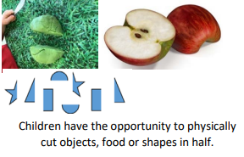  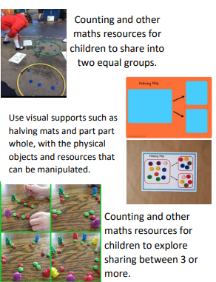 | 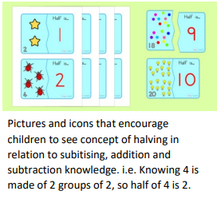  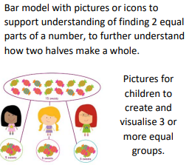
Language | Share same equal half
Resources | sorting equipment and real life items halving mats

Division Year 1
Progression of calculation | Concrete | Pictorial | Abstract
Halving 0-20  0-20 ÷O  - Working practically to share and group. | 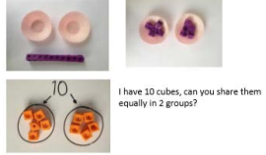 | 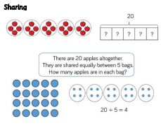  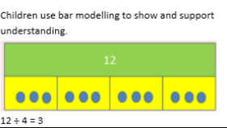  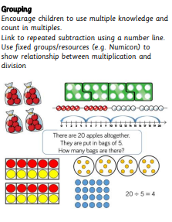 | 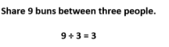
Language | Half Grouping Halve Share Division Equal Dividing
Resources | Tens frames Straws Arrays Bead strings Number lines

Division Year 2
Progression of calculation | Concrete | Pictorial | Abstract
Halving 0-40 TO÷)  (using jottings and equipment in context)  TO÷2,5,10 (using known facts) TO÷2,5,10 (with remainders)  - Recall and use division facts relating to known times tables  - Divide larger numbers by partitioning into tens and ones.  - Multiplication and division taught alongside each other to show relationship. | 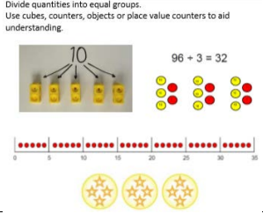  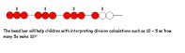 | 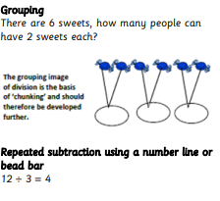  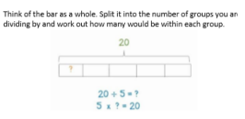 | 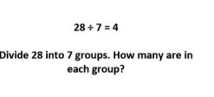  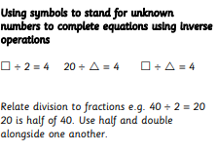
Language | Half Grouping Halve Share Division Equal Dividing Divided by Divided into Equal groups of
Resources | Tens frames Straws Arrays Bead strings Number lines

Division Year 3
Progression of calculation | Concrete | Pictorial | Abstract
TO ÷ (2,3,4,5,8,10)  – answers between 0 and 10.  TO ÷ (2,3,4,5,8,10)  – answers between 1 and 10 with remainders.  - Divide 100 into 2, 4, 5 or 10 equal parts by practising counting multiples of 10, 20, 25 or 50.  Use of both methods:  • Grouping  • Sharing | 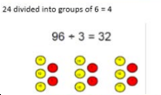  Division with arrays – use practical resources to make arrays to see the groups  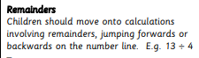  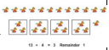  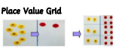 | Division with arrays  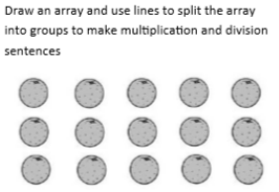  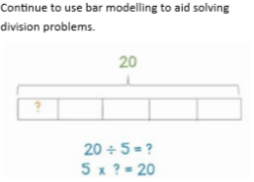  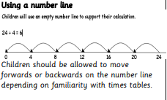  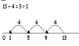  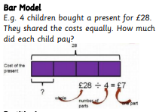 | 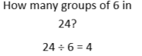  Arrays  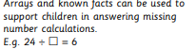  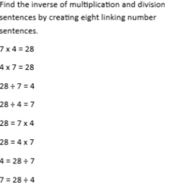  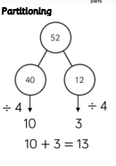
Language | All previous words Dividend – the number that is divided. Divisor – the number by which another is divided Factor – a number that multiplies to make another product. Quotient – the result of a division Remainder – the amount left over when the divisor is not a factor of the dividend. Scaling – enlarging or reducing a number by a given amount. Inverse – the opposite in effect.
Resources | Diennes/Base 10/Big Base Numicon Counters Multiplication Squares Bead Strings Empty Number Line Number Tracks/Number Lines Place Value Counters/ Place value grid/Place Value Calculation Mat Place Value Sliders Bar Models
Division Year 4
Progression of calculation | Concrete | Pictorial | Abstract
O ÷ O = answers 0 – 10  TO ÷ O = answers greater than 10. As above including remainders. - Divide 1000 into 2, 4, 5 or 10 equal parts by practising counting multiples of 100, 200, 250 or 500. Divide 2-digits by 1-digit (grouping) | 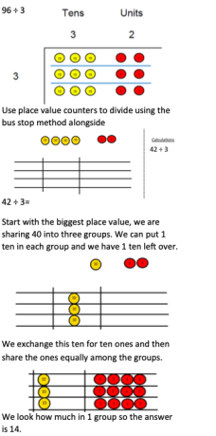 | 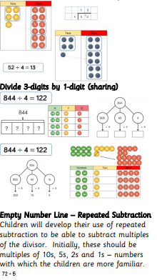  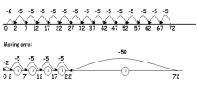  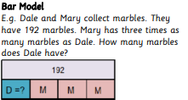 | 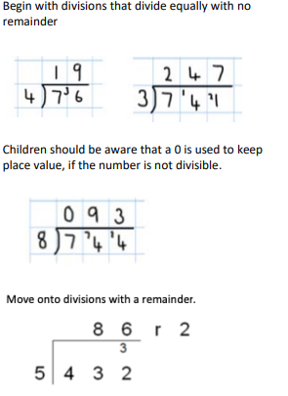
Language | All previous words Dividend – the number that is divided. Divisor – the number by which another is divided Factor – a number that multiplies to make another product. Quotient – the result of a division Remainder – the amount left over when the divisor is not a factor of the dividend. Scaling – enlarging or reducing a number by a given amount. Inverse – the opposite in effect.
Resources | Diennes/Base 10/Big Base Numicon Counters Multiplication Squares Bead Strings Empty Number Line Number Tracks/Number Lines Place Value Counters/ Place value grid/Place Value Calculation Mat Place Value Sliders Bar Models

Division Year 3
Progression of calculation | Concrete | Pictorial | Abstract
TO ÷ (2,3,4,5,8,10)  – answers between 0 and 10.  TO ÷ (2,3,4,5,8,10)  – answers between 1 and 10 with remainders.  - Divide 100 into 2, 4, 5 or 10 equal parts by practising counting multiples of 10, 20, 25 or 50.  Use of both methods:  • Grouping  • Sharing | Division with arrays – use practical resources to make arrays to see the groups | Division with arrays | Arrays
Language | All previous words Dividend – the number that is divided. Divisor – the number by which another is divided Factor – a number that multiplies to make another product. Quotient – the result of a division Remainder – the amount left over when the divisor is not a factor of the dividend. Scaling – enlarging or reducing a number by a given amount. Inverse – the opposite in effect.
Resources | Diennes/Base 10/Big Base Numicon Counters Multiplication Squares Bead Strings Empty Number Line Number Tracks/Number Lines Place Value Counters/ Place value grid/Place Value Calculation Mat Place Value Sliders Bar Models
Division Year 5
Progression of calculation | Concrete | Pictorial | Abstract
TO÷O  - HTO÷O=TO  - HTO÷O=HTO  - THTO÷ O =  - Using a bar model to support problem solving in division  -Divide by 10, 100 and 1000 and understand how this affects a number’s place value.  Grouping to support Short Division | Children will use concrete and pictorial resources to support grouping when using short division with progressively larger numbers  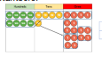  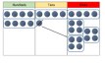  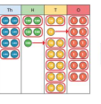 | Children will use concrete and pictorial resources to support grouping when using short division with progressively larger numbers | 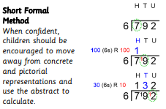  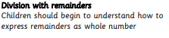  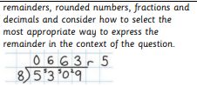  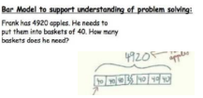
Language | All previous words Dividend – the number that is divided. Divisor – the number by which another is divided Factor – a number that multiplies to make another product. Quotient – the result of a division Remainder – the amount left over when the divisor is not a factor of the dividend. Scaling – enlarging or reducing a number by a given amount.
Resources | Diennes/Base 10/Big Base Numicon Counters Multiplication Squares Empty Number Line Number Tracks/Number Lines Place Value Counters/ Place value grid/Place Value Calculation Mat Bar Models

Division Year 3
Progression of calculation | Concrete | Pictorial | Abstract
TO ÷ (2,3,4,5,8,10)  – answers between 0 and 10.  TO ÷ (2,3,4,5,8,10)  – answers between 1 and 10 with remainders.  - Divide 100 into 2, 4, 5 or 10 equal parts by practising counting multiples of 10, 20, 25 or 50.  Use of both methods:  • Grouping  • Sharing | Division with arrays – use practical resources to make arrays to see the groups | Division with arrays | Arrays
Language | All previous words Dividend – the number that is divided. Divisor – the number by which another is divided Factor – a number that multiplies to make another product. Quotient – the result of a division Remainder – the amount left over when the divisor is not a factor of the dividend. Scaling – enlarging or reducing a number by a given amount. Inverse – the opposite in effect.
Resources | Diennes/Base 10/Big Base Numicon Counters Multiplication Squares Bead Strings Empty Number Line Number Tracks/Number Lines Place Value Counters/ Place value grid/Place Value Calculation Mat Place Value Sliders Bar Models
Division Year 6
Progression of calculation | Concrete | Pictorial | Abstract
HTO ÷O (with decimal and fraction remainders, depending on context) HTO ÷ TO  THTO ÷TO  O.t ÷O  TO.t ÷O  All methods below will be viewed as formal methods  Children should understand how to express remainders as whole number remainders, rounded numbers, fractions and decimals and select the most appropriate way to express the remainder in the context of the question |  | 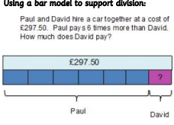 | 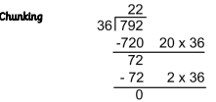  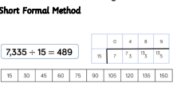  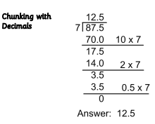
Language | All previous words Dividend – the number that is divided.  Divisor – the number by which another is divided  Factor – a number that multiplies to make another product.  Quotient – the result of a division  Remainder – the amount left over when the divisor is not a factor of the dividend.  Scaling – enlarging or reducing a number by a given amount.
Resources | Diennes/Base 10/Big Base Numicon Counters Multiplication Squares Empty Number Line Number Tracks/Number Lines Place Value Counters/ Place value grid/Place Value Calculation Mat Bar Models

