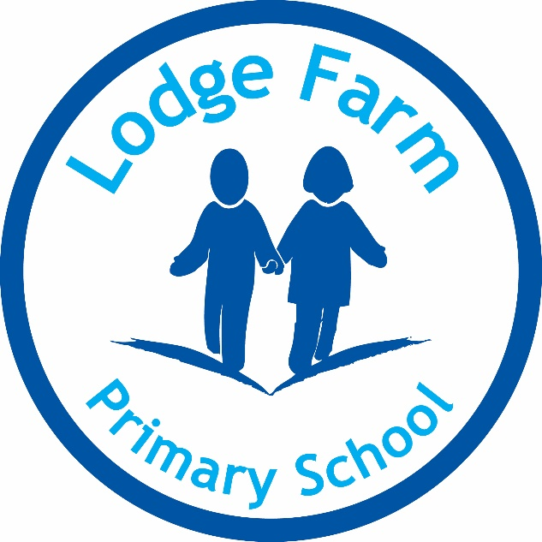

Art and Design Policy

O Ledgester

December 2022

Approved by Chair: _____________________

Review Date: __________________

Art and Design Policy

This policy describes the current provision for Art and Design at Lodge Farm Primary School, as defined in the National Curriculum 2014. It will illustrate the aims, entitlement, curriculum, management and assessment of Art and Design.

Aims and objectives
As stated in the National Curriculum:
‘Art, craft and design embody some of the highest forms of human creativity. A high-quality Art and Design education should engage, inspire and challenge pupils, equipping them with the knowledge and skills to experiment invent and create their own works of art, craft and design. As pupils progress, they should be able to think critically and develop a more rigorous understanding of Art and Design. They should also know how Art and Design both reflect and shape our Art and Design, and contribute to the culture, creativity and wealth of our nation.’

Intent
At Lodge Farm through the subject of Art and Design we aim for every child to develop their confidence when producing creative work, generating their ideas, whilst learning about famous artists, architects, designers and a variety of different cultures. Expressing themselves through Art and Design, whilst supporting and nurturing their academic, personal and emotional well-being, and providing a vast range of experiences to broaden their expectations of their own capabilities through: drawing, painting, sculpture and other areas of Art and Design. This subject allows children to succeed even when they may be faced with barriers within their written and verbal communication. Here at Lodge Farm, we strive to provide every single child to feel a sense of achievement and experience success during their time at our school. Our children are unique individuals with their own interests and dreams. As a school community, we will support each child to make the most of every opportunity that we offer.

The key drivers for our curriculum are:
- Aspiration
- Healthy Lifestyle
- Communication
- Knowledge of the World

What do our drivers look like in your subject?

Subject: Art and design
Aspiration | At Lodge Farm, all pupils are encouraged to explore through creating whilst learning a variety of skills and famous artists. Pupils work collaboratively to explore a range of resources and materials, and for children to identify their personal interests. Every pupils work is highly valued and pupils are taught to always try their best allowing them to excel.
Healthy Lifestyle | Alongside pupils studying famous artists, art is fantastic for mental wellbeing, it allows you to relax whilst being creative. It is a great way to gather your thoughts and reflect upon situations. Pupils are taught art can link to other subjects such as PSHE and behaviour management.
Communication | In lessons, pupils and teachers communicate, to discuss and evaluate their work. Pupils can name artists, define key skills and use subject specific language to talk about artists they like. Pupils communicate with the teacher formally at the end of each unit through ‘self-assessment’, ticking off objectives they feel they have met during that unit.
Knowledge of the World | At Lodge Farm, pupils are taught about local art and artists. Pupils are taught how to work collaboratively and work is shared through the website, newsletters as well as class.

Early Learning Goals
Children in the EYFS safely use and explore a variety of materials, tools and techniques, experimenting with colour, design, texture, form and function. Children then build on these skills in Key Stage One by using drawing, painting and sculpture to develop and share their own ideas, experiences and imagination.

Subject content for Key Stage 1
In Key Stage One, children begin to use sketchbooks to capture their Art journeys. Using sketchbooks helps children to develop their critical thinking skills, capture their Art progress and improve the mastery of techniques.

Pupils should be taught:
- To use a range of materials creatively to design and make products.
- To use drawing, painting and sculpture to develop and share their ideas, experiences and imagination.
- To develop a wide range of art and design techniques in using colour, pattern, texture, line, shape, form and space
- To learn about the work of a range of artists, craft makers and designers, describing the differences and similarities between different practices and disciplines, and making links to their own work.
​

Subject content for Key Stage 2
Pupils should be taught to develop their techniques, including their control and their use of materials, with creativity, experimentation and an increasing awareness of different kinds of art, craft and design.

Pupils should be taught:
♣ To create sketch books to record their observations and use them to review and revisit ideas
♣ To improve their mastery of art and design techniques, including drawing, painting and sculpture with a range of materials [for example, pencil, charcoal, paint, clay]
♣ To lean about great artists, architects and designers in history.

Implementation
In KS1, to use a range of materials creatively to design and make products. The children will be drawing, painting and sculpture to develop and share their ideas, experiences and imagination. The children will be using sketching pencils, oil pastels, paint, creating collages, sculpting and using a range of materials. All children will develop a wide range of art and design techniques in using colour, pattern, texture, line, shape, form and space. They will learn about the work of a range of artists, craft makers and designers, describing the differences and similarities between different practices and disciplines, and making links to their own work. The children will be making steady progression as they move into KS2. In KS2, pupils should be taught to develop their techniques, including their control and their use of materials, with creativity, experimentation and an increasing awareness of different kinds of art, craft and design. All pupils will create sketch books to record their observations and use them to review and revisit idea. All pupils will have the opportunity to improve their mastery of art and design techniques, including drawing, painting and sculpture with a range of materials [for example, pencil, charcoal, paint, clay. The children will use digital technology about great artists, architects and designers in history.

Resources
We have a wide range of resources to support the teaching of Art and Design across the school. All our classrooms have a range of basic resources, but we keep the more specialised equipment in the Art and Design cupboard. This room is accessible to pupils only under adult supervision.
A resource audit is carried out to ensure that resources are kept up to date and are available to support teaching and learning. In addition to this, a wide range of resources have been ordered to support the changes to the National Curriculum.

Progression
Pupils learn art and design through the different strands such as developing and generating ideas, drawing, painting, collage, sculpture, textiles, printing and work of other artists. These strands often interweave and are almost all covered termly across all year groups. Progression is developed through the repetition and depth of learning within these strands.

Impact
We believe that our own schools ethos is the basis of our curriculum and art is loved by teachers and pupils across school, teachers have higher expectations and more quality evidence can be presented in books. All children will use Art and design vocabulary accurately and understand the different strands Art and design, with a deep understanding of the famous artists and how to create an art piece. Children will begin to make relevant links from art to other curriculum subjects, such as history, science and geography. Children will improve their vocabulary, and improve on a range of skills. All children in the school will be able to speak confidently about their Art and design learning, skills and knowledge.

Inclusion

In planning work the teachers will aim to:
- provide breadth and balance of art activities for all pupils
- set suitable learning challenges for individuals or small groups of pupils
- respond to pupils diverse learning needs
- liaise with the Special Needs Co-ordinator to ensure that provision is made for all SEND pupils.

Cross-Curricular links

English
Art and Design contributes to the teaching of English in our school by encouraging pupils to ask and answer questions about the starting points for their work, and lead research of their own. They have the opportunity to compare ideas, techniques and approaches in their own work and that of other pupils, and to say what they think and feel about them.

Mathematics
Art and Design contributes to pupils' mathematical understanding by giving opportunities to develop the pupils’ understanding of shape and space through work in two and three dimensions.

Personal, Social and Health Education (PSHE) and Citizenship
Art and Design contributes to the teaching of some elements of personal, social and health education and citizenship. The pupils discuss how they feel about their own work, and the methods and approaches used by others. They have the opportunity to meet and talk with artists and other talented adults during their work.
Spiritual, moral, social and cultural development
The teaching of Art and Design offers opportunities to support the social development of our pupils, through the way we expect them to work with each other in lessons. Groupings allow pupils to work together, and give them the chance to discuss their ideas and feelings about their own work and the work of others. Their work in general helps them to develop a respect for the abilities of other pupils, and encourages them to collaborate and cooperate across a range of activities and experiences. The pupils learn to respect and work with each other and with adults, thus developing a better understanding of themselves. They also develop an understanding of different times and cultures, through their work on famous artists, designers and craftspeople.
Computing
Computer technology enhances our teaching of Art and Design, wherever appropriate, in all key stages. Pupils use software to explore shape, colour and pattern in their work. Older pupils collect visual information to help them develop their ideas by using digital and video cameras, scanners, digital microscopes and digitising tablets. They record their observations, and they manipulate them through photo-editing or painting software. The pupils also use the Internet, to find out more about the lives and works of famous artists and designers, and to assemble their own presentations about them.

Health and Safety
We are aware of health and safety aspects in the delivery of the Art Curriculum.
It is important that the pupils learn to use potentially dangerous tools properly and that potentially hazardous tools (such as sharp scissors, lino cutters, certain glues) be stored away in a safe place.
Pupils should always be encouraged to wear protective clothing. The substances that pupils may be required to use within school are:

- Water based paints, inks, glue, clay, plaster of paris.

Pupils are always supervised and are instructed on the safe use of substances used within the school.

Staff must ensure they have modelled the safe and correct usage of all tools and equipment prior to the pupils’ use. Hand washing procedures must take place after the handling of all materials and resources. Mod-roc (a plaster covered bandage) may be used to construct sculptures and casts (such as face masks). The use of Mod-roc is always under strict adult supervision.

